EXPERIMENT 7: DEVELOP LOW-FIDELITY PAPER PROTOTYPES FOR A BANKING APP AND CONVERT THEM INTO DIGITAL WIREFRAMES USING INKSCAPE

Name:Jovitha J Roll number: 240701219

Aim:
The aim of this experiment is to design and evaluate a banking application interface by first creating low-fidelity paper prototypes and then converting them into digital wireframes using Inkscape. The purpose is to demonstrate how iterative prototyping improves clarity, usability, and user-centric design while transitioning from conceptual sketches to refined digital layouts.

Core Features
- Object Creation Tools:
  - Pencil, Pen, and Calligraphy tools for freehand drawing and Bézier curves.

Object Manipulation:
  - Move, scale, rotate, skew objects interactively or with numeric precision.

Styling s Colors:
  - Fill and stroke options with multiple color models (RGB, CMYK, HSL).

Procedure:

Requirements Planning
  - Identify core features: secure login, account balance display, withdrawal, deposit.
  - Define navigation flow: Login → Dashboard → Withdraw/Deposit → Confirmation.

Paper Prototyping
  - Sketch each screen on paper:
    - Login page with username/password fields and buttons.
    - Dashboard showing account balance and navigation options.
    - Withdraw and Deposit pages with amount fields and action buttons.

Testing and Refinement
  - Collect feedback from peers or stakeholders.
  - Refine layouts and interactions based on usability feedback.

- Login Page:
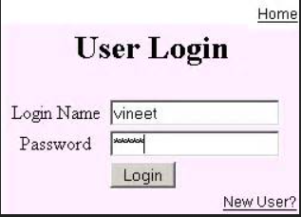
- Dashboard

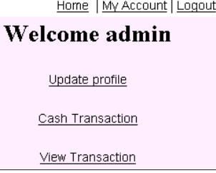

- Deposit page
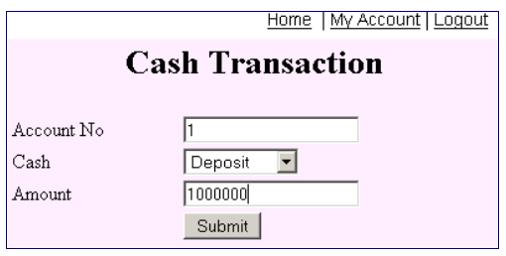

Result:
The experiment demonstrated how low-fidelity paper sketches can be effectively transformed into digital wireframes using Inkscape. By iteratively refining layouts, the banking app prototype achieved clarity in navigation and functionality across login, account balance, withdrawal, and deposit screens. This highlights the value of combining quick paper prototyping with precise digital tools to create user-friendly, scalable UI designs.

